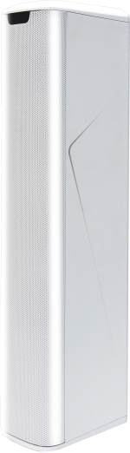
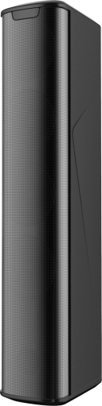
3” 100W Line Array Column Speaker system FPR-L8 (Similar JBL CBT50)
Description:
This Line Array Speakers come with such sound enhancing benefits as clear sound, excellent directionality of focus on the listening area, and transmission of clear, even sound over a distance, thanks to a low degree of sound attenuation. These speakers are well-suited for medium-sized mainly speech applications where clear, uniformly dispersed sound that is audible at a distance is essential, such as conference centers, houses of worship and railway stations, or venues with highly reflective interior surfaces. The line array speakers work to provide high quality sound even when an equalizer is not used. The speaker units come in a slim, energy-efficient and cost-effective design, with a body that is narrower than earlier versions, so they are well-suited to a wide range of venue indoor & outdoor.
Waterproof and 100V input with taping versional is Optional.

Features:
- 3” Line Array Speaker System
- Indoor professional installation loudspeakers
- Enhanced directional focus and even sound coverage
- Ideal for conference room, worship area and railway stations
- Power output 100W, 8ohms
- 4 units of 3” special ferrite driver unit and paper cone
- Waterproof removable speakon input connector

Specifications:
Model | FPR-L8
Description | Line Array Speaker System
Enclosure | Bass-reflex type
Rated Power Output | 100W, 8ohms
Line Input | 8ohms
Sensitivity(1W/1m) | 98dB, max 123db
Frequency Response | 150Hz~14kHz，-6dB；80Hz~20kHz，-10dB；
Directivity Angle | Horizontal: >120°, Vertical: >20°
Speaker Component | 4"× 3units
Input Connector | Removable Speakon input connector
Finish | ABS+ fiber glass
Dimensions | 530(W) × 100(H) × 150(D) mm
Weight | 5.38kg

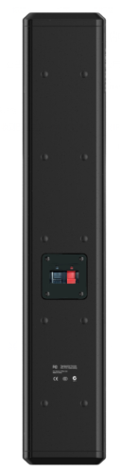
3” 100W Line Array Column Speaker Syste m FPR-L8 (Similar JBL CBT50)

Frequency Response:
